**WEEK 1 Portfolio Diversification and Supporting Financial Institutions I**

1. Leverage

2 for 1 leverage

2. Equity Premium

* Stock are riskier, and the price of stocks jumps up and down day to day.
* Extra return is a risk premium
* Markowitz 1952, Journal of Finance
* Trade-off of risk and return

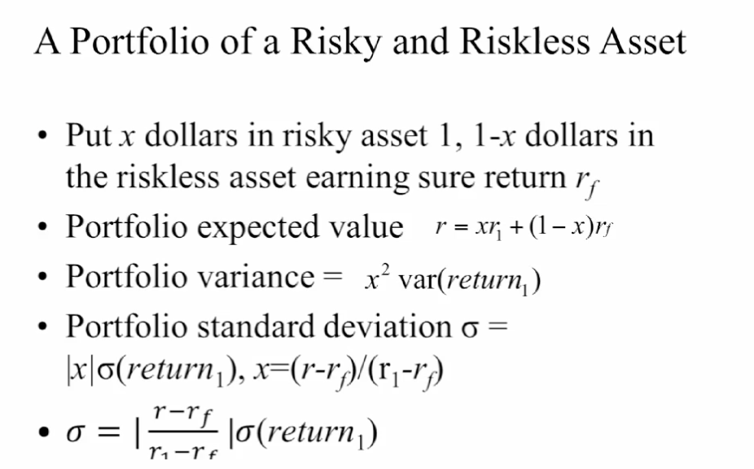

3. Pure leverage

rf: r sub f

**Portfolio Diversification and Supporting Financial Institutions II**

